“Chopped’ Speech Directions

You will need to bring a “chopped” version of your speech tomorrow. Essentially, you want to bring each sentence or pairs of sentences in on individual pieces of paper.

Directions:

- Triple space your document
- Hit enter a few times after every period
- You may keep together a few sentences that ABSOLUTELY need to be in that order and next to each other
- Print
- Cut into strips of paper
- Place in an envelope or equivalent containment device
- Bring to class the next day

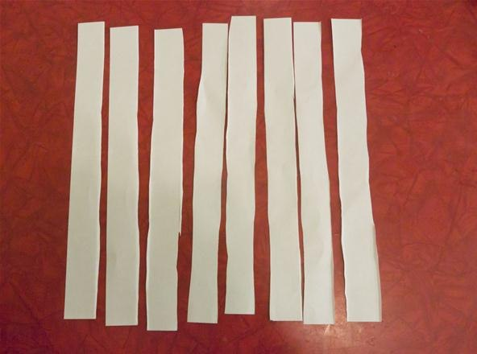
It will look like this (only with words on the paper)

<<<<<<<<<<<

